Shabbos Stories for
Parshas balak 5781
Volume 13, Issue 44 16 Tammuz/June 26, 2021
Printed L’illuy nishmas Nechama bas R’ Noach, a”h

For a free subscription, please forward your request to keren18@juno.com
Past stories can be found on the website ShabbosStories.com

The Righteous Taxi Driver
By Rabbi Reuven Semah

Recently a young man named Yitzhak was visiting Kiryat Yoel, also known as Palm Tree, in Orange County, NY. He was on his way out of Kiryat Yoel, and wished to get a ride to the entrance of the community, from where he would travel to Brooklyn.
As he stood at the curb, a car pulled up to give him a ride. Yitzhak immediately noticed that the car, a taxi cab, was being driven by a Jewish religious taxi driver. It was a bit awkward for a moment, as Yitzhak had been looking for a hitch – a free lift – and didn’t want to pay a taxi fare for a brief ride. He gently informed the taxi driver that he was waiting for a hitch, not a taxi.”
“No problem,” said the driver. “Come in. I’m not charging you.”
As he sat down and closed the car door, Yitzhak asked, “But don’t you drive a taxi for a living? What do you mean that you’re not charging me?”
The driver smiled as he pulled away from the curb. Turning to his passenger he explained, “During the day I drive this car as a taxi, so I have to charge money. But I don’t have an opportunity at that time to do hesed. Each day, however, my boss gives me a one hour lunch break. During that time, I can do the misvah of hesed by providing rides free of charge.”
There is something so pure about the response of this taxi driver.

(Reprinted from the Parshat Beshalach 5781 email of Shabbat Shalom from Cyberspace (compiled by Rabbi David Bibi).

The Lost Pair of Tefillin

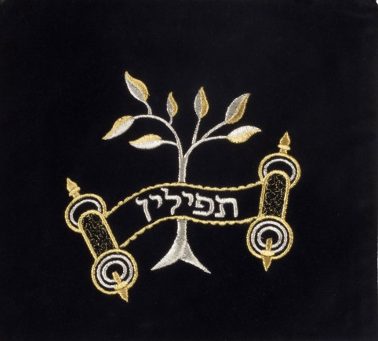

Rabbi Yechiel Spero told a story about how about a woman name Sarah who went above and beyond to return a lost pair of tefillin. A new couple had just moved to Baltimore, and on their first Shabbat as newlyweds, the bride, Sarah, escorted her husband to shul on Friday night. She wanted to keep him company, so she went to the women’s section before Shabbat started. The women’s section in that shul is a Bet Midrash during the week, and it was pretty messy. She began to tidy up the books a little.
While she was putting the sefarim on the shelves, she uncovered a tefillin bag buried underneath. Sarah took it and put it on a noticeable shelf, where no one would have to look far to find it. After she cleaned up, she admired her work and decided she would do this weekly.
The next Friday, she went early to organize, and she noticed the tefillin were still there on the shelf, and the next week and the week after that as well. Clearly, whoever was missing the teffilin was not wearing them, and it upset her. Sarah put up a sign that said, “Whoever knows whose tefillin these are please call this number.” And she put a picture of the bag and took it home with her for safekeeping.
Weeks later, she got a phone call from a woman who said, “My husband told me there is a sign in the Bet Midrash, and he sent me the picture, and I think I recognize the name on the bag. I’m almost sure it belonged to my old neighbor’s son. The family moved to Israel five years ago. I haven’t been in touch, but I have the mother’s number.”

Telephoned the Woman in Israel
Sarah quickly took the number and called the woman in Israel. It rang twice and then was declined, so she left a message saying she had her son’s tefillin.
Two minutes later, her phone rang. It was the woman in Israel. Sarah proceeded to tell her the whole story about how she was organizing, and how the tefillin were in the shul. And after her story, she said, “So tell me, is your son looking for his tefillin?” Sarah heard silence on the line, and then some muffled cries. The woman began to speak.
“My son had unfortunately gone off the derech about five years ago. He struggled terribly and decided to stop wearing his tefillin. Our relationship has been extremely strained, and it’s been so so hard for me. We speak once or twice a year when he needs something.

The Errant Son Called His Mother
“Today my son called me, and he said, ‘Ma, I think I want to come home. I think I’m going to start praying again. Do you know where my tefillin are?’ And when he asked his question, your number came across my screen. I told him I would try to find them, and I hung up, only to listen to your voicemail saying you had them. So, yes. To answer your question, my son is looking for his tefillin.”
The boy got his tefillin and was chozer beteshuvah. That is the significance of looking out for your fellow Jew. Sometimes, we drift. This year, this week, it’s been especially hard. It’s been a difficult journey. But we have risen and achieved unimaginable things. We must look out for one another, and Hashem will bring Mashiach quickly and easily!

Reprinted from the Parshat Beha’alotcha 5781 email of Jack Rahmey based on the Torah teachings of Rabbi Amram Sananes.
Water Sanctification
By Rabbi Yosef Weiss

A large utility truck obstructed R’ Aaron Yosef Berger’s view as he left his house one morning on his way to the Kollel. “United Water,” read the lettering on the side. As he passed, R’ Aaron Yosef noticed utility workers emerging from the home of one of his neighbors down the block.
“Uh-oh,” he thought to himself. “They must be shutting off the water. I knew they weren’t doing so well financially.” R’ Aaron Yosef mulled unhappily over the situation. He remembered how, not too long ago, the water company had mistakenly cut off the water supply in his own home. How aggravating it had been! The lack of running water disrupted the entire household. No washing, no drinking, no cooking. Even the basic necessities were impossible. The entire day had just turned into complete havoc. “How can I just allow my neighbor’s water to be shut off? How can I allow him to go through such a frustrating experience?”
When he reached his neighbor’s house, the truck was just pulling out of the driveway. “Wait!” R’ Aaron Yosef called, waving his arms frantically as he tried to flag the driver down. “Please stop!”
The man stopped the truck, startled. He got out of the driver’s seat and looked at R’ Aaron Yosef in puzzlement. “What’s the problem?” “Did you shut off the water?’ R’ Aaron Yosef asked.
“Yes, that’s right.”

Offers to Pay the Bill
“I’ll pay the bill. Please turn it back on!” he pleaded.
“What? What are you talking about?” the man asked in bewilderment.
R’ Aaron Yosef hesitated. “Didn’t you say that you shut off the water?”
“Yes, I did.”
“So, if he didn’t pay his bill, I’m going to pay it right now.”
“Do you live here?” asked the utility worker.
“No.”
You’re just passing by, and you want to pay some stranger’s bill?” the man clarified, incredulous.
“Well, yes, my neighbor’s.”
“Actually, we’re not shutting off the water because of an unpaid bill. There’s a water main leak, and we have to shut off the water to fix it. But I can’t believe you were willing to pay his bill like that!”

Amazed by the Reaction of the Utility Worker
R’ Aaron Yosef watched, startled, as the utility worker pulled off the necklace around his neck. A stream of vulgar language spewed forth from his mouth as he cast his religious symbol to the ground and stamped on it. “This is no religion! You Jews are amazing! Unbelievable! You must have the right G-d!”
He called over his partner, who was still sitting inside the truck. “You hear this? This man wanted to pay his neighbor’s bill!”
R’ Aaron fidgeted nervously, anxious that his neighbor might emerge from the house and witness the scene. He apologized to the men for disturbing their work and made a quick getaway to his Gemara in the Kollel.
As R’ Aaron Yosef settled into his seat, he began his learning with a feeling of joy at his merit to perform a true Kiddush Hashem. (Visions of Greatness 8)

(Reprinted from the Parshat Beshalach 5781 email of Shabbat Shalom from Cyberspace (compiled by Rabbi David Bibi).

The Chacham and
The Broken Furnace

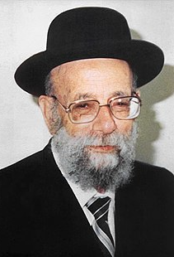

One of the great Sephardic Chachamim of the previous generation was Chacham Rabbeinu Yehudah Tzadka zt”l, Rosh Yeshivah of Yeshivat Porat Yosef in Jerusalem. Rav Yehudah was a Tzaddik who was characterized by his love of Torah and Talmidei Chachamim, as well as his desire and alacrity to perform mitzvos.
He lived simply, did not indulge in any extravagances, and encouraged his students to be content without luxuries. He maintained a tremendous level of Emunah and Bitachon in Hashem. Rav Yehudah placed his full trust in the Almighty and there was nothing too big or too small, in which he did not see the Yad Hashem actively helping him.

The Furnace in the Tzadka Home Gave Out
It is told that one winter, the furnace in the Tzadka home finally gave out and it was clear that a new system would be necessary to ward off the bitterness of the cold Jerusalem winters.
Rav Yehudah was walking to yeshivah one day and he happened to pass an electrical appliance store. He paused and looked inside. Indeed, they sold furnaces and he was ready to walk inside and see how much it cost. But then he stopped and realized that no matter what it cost, he couldn’t pay for it since he had no money on him at all.
He stood in the street facing the store and thought about what to do. Suddenly, a man approached him and extended his hand. “Rabbeinu, Shalom Aleichem. I am so happy to meet you here at this time. Honestly, I just happened to be in Jerusalem today and was walking by when I noticed the Rav. It is truly my honor and good fortune. Please allow me to repay a debt from quite some time ago.”

Couldn’t Remember Any Debt that was Owed Him
Rav Yehudah recognized the man, but could not remember any debt that was owed to him by the man. When Rav Yehudah asked about it, the man replied that a number of years ago, after his father had passed away, Rav Tzadka traveled all the way from Jerusalem to Tel Aviv to attend the funeral. He delivered a moving and emotional hesped for the man’s father, who was an old acquaintance of the Rav, and it was a great honor that he came.
“At the time,” said the man, “I thought about how nice it was that the Rav came and how I wanted to pay him back for his expenses. Additionally, I wanted to show my appreciation by giving the Rav a little extra. Unfortunately, due to the circumstances and the timing, I forgot and the Rav went back to Jerusalem. I had totally forgotten about it until this moment when I happened to come to Jerusalem and what do you know - I meet the Rav in the street!”
The man pulled a wad of bills from his pocket and counted off a considerable amount. He handed it to Rav Tzadka and apologized to him again from the bottom of his heart for taking so long to pay off his debt. Rav Yehudah smiled and thanked the man for his graciousness and generosity. Although under normal circumstances, he would not take money or gifts from anyone, in this situation he recognized the Yad Hashem and how much it meant to the man from Tel Aviv.

The Rav Uttered a Prayer of Deep Thanks
The man walked away and Rav Yehudah uttered a prayer of deep thanks to the Almighty for always seeing to his needs. With the cash in his hand, he walked into the appliance store and inquired about purchasing a furnace.
The store owner told him the price and Rav Yehudah realized that although the man had given him quite a sum of cash, he was still short a few hundred shekels. He still did not have enough money to buy the furnace, and with a pleasant smile, he thanked the store owner and walked back outside into the cold Jerusalem street.
Once again, Rav Yehudah stood facing the store and mulled over his options. And just like the first time, the same man from Tel Aviv came around the corner and walked right over to him. “Rabbeinu, again I must apologize. I only gave you the money for coming and delivering the hesped. I forgot to give you money for your travel expenses. Here is the rest of the money that I owe the Rav. Thank you again.”
The man handed him another set of bills and walked away. When Rav Tzadka looked down, he saw that the man had added a few hundred shekels to his “debt” - as it turns out, the exact amount required to purchase the furnace. He smiled, thanked Hashem and walked back into the store.

Reprinted from the Parshas Behaaloscha 5781 email of Torah Tavdil (Rabbi Dovid Hoffman).

The Polish Draft Notice

There was once a chasid by the name of Reb Mottel Gruman, who grew up in Warsaw at the turn of the 20th century. He was a big, strong, healthy young man and when he received a draft notice from the Polish army, he was sure that there would be no way for him to get a deferment like many others did, as he really had no excuse.
He decided to go to the Rebbe of Sochatchov, R’ Avraham Bornstein zt”l (Avnei Nezer) and plead for a blessing that he might be dismissed from military service.
The Rebbe knew his family well and as soon as he asked for a beracha, the Sochatchover replied, “You are a Levi and the Torah says that Leviim do not serve.”
Young Mottel reported to the army base and when they saw what a strapping man he was, he was instantly taken in and sent to a military camp far away. There, he sat for six months, but a strange thing happened: for some inexplicable reason, nobody paid him any attention. It was as if he didn’t exist. The military personnel simply forgot all about him and he never once was asked to do a thing in the camp. Meanwhile, Mottel had to eat so he found some crackers and sardines, and drank a lot of water. Over six months’ time, this meager diet wreaked havoc on his internal system and he lost a lot of weight. He became weak, so weak that after a while, he had trouble walking. When the camp authorities finally noticed him after six months, they saw this weak thin Jewish boy and immediately sent him home!

Reprinted from the Parshas Behaaloscha 5781 email of Torah Tavdil (Rabbi Dovid Hoffman).
That Special Shabbos Candle

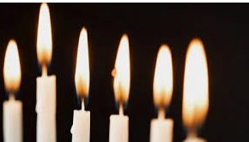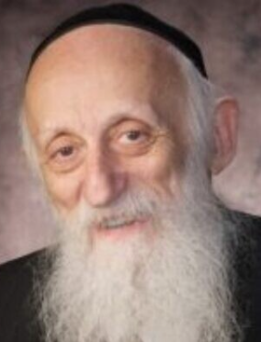

One of the reasons that we grow up not focusing on our identity is that we lack a sense of adequacy and wholesomeness which allows a more satisfactory adjustment to life. One who does not feel good about himself hardly has the motivation to focus on establishing his identity.
Rabbi Abraham Twerski, M.D. relates a beautiful and meaningful thought which I feel applies to us all across the board. It was Friday night, and they had guests at their Shabbos table. One of the guests, who was apparently not very knowledgeable about Jewish tradition, asked his mother why six candles were burning on the Menorah, rather than the usual two.

An Additional Candle for Each New Child
It was explained that in most families, when one marries, she begins lighting two candles and, with the ensuing birth of each additional child, she adds another candle.
Rabbi Twerski, who was a young boy at the time, remembers how good he felt in the knowledge that one of the candles that his mother lit Friday night was for him. He realised that the world was now a brighter place because of him.
Rabbi Twerski did not feel the fulfilment of this powerful message until years later when, in the course of his psychiatric practice, it became evident that countless people suffer from emotional problems and varying psychological symptoms due to deep-seated feelings of inadequacy.
He poignantly sums it up: The weekly message to a child, conveyed at the initiation of Shabbos kodesh, that his/her existence has brought additional brightness into the home, can be a powerful stimulant for personal development.

(Reprinted from the Parshas Behaalosecha 5781 email of Peninim on the Torah (Rabbi A.L. Scheinbaum).
Covering with Light
As with a Garment
By Beis Shin

My wife is just as good-hearted as her mother a”h, always tending to the weak and concerned for their needs. On her way to work, she saw a woman collecting donations. Aside from the perutah she gave to tzedakah, she would ask how they were doing, and she would speak with them.
The woman’s husband lost his business, their house and belongings were taken from them, having no choice she went out collecting. One day it was bitter cold, and my wife saw her collecting without a coat, just a thin shawl, not enough to protect from the cold.
My wife asked why she wasn’t wearing a coat? She simply said she was not cold. She said she was not cold, but her hands were shaking from the cold. My wife felt, how could she go to work where it was nice and warm while this woman was on the street corner?!
She immediately took off her coat and gave it to her. The woman tried to refuse but my wife was firm. That night when my wife told me what happened, I asked her why she gave her her coat? We could have bought her a cheap one or find one for her at a gemach!?
But my wife would not hear a word about it, and she could not understand how I could leave the woman out in the cold like that? “I can go from home to work in a shawl, but how could I leave her out in the street all day!!”
What could I say? The next day I received a call from a friend who I had not spoken to in a while, and in the middle of our conversation, out of the blue, he said, “Now it is cold in Israel and I want you to buy your wife a good warm coat. I am sending you $400!!!”
I do not know where this came from, but I did not say a word about the coat, it was a random sentence in the midst of a conversation, totally out of context. I saw how HaKadosh Baruch Hu sees and knows everything and is mercifully concerned for all His creations. With this money my wife bought two good coats and had money left over for warm shawls. From then on, I do not mix into the acts of kindness of my wife.

Reprinted from the Parshas Beha’alosecha 5781 email of Tiv Hakehila.

To Teach or Not
To Teach Torah
By Rabbi Dovid Goldwasser

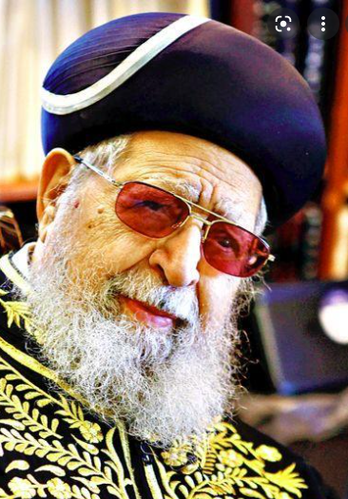
Rav Ovadia Yosef

Almost 50 years ago, Rav Reuven Elbaz was asked to give a shiur in one of the older shuls in Yerushalayim. He was still a young man, immersed in Torah learning, and after calculating the time he would lose from his own personal studies as a result – two hours traveling for just a short half-hour lecture – he decided to opt out.
Instead, he attended a shiur given by Rav Ovadia Yosef. Afterwards, the chacham called him over and said, “I heard that you were asked to give a Torah shiur.”
Rav Elbaz said, “What would be with my own learning?”

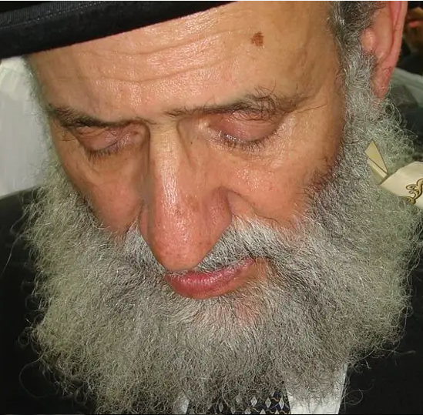
Rav Reuven Elbaz

Rav Ovadia responded, “And these people who have no one to teach them even one halacha should go without any Torah?”
“I want to grow in my own Torah learning,” protested Rav Elbaz, to which the chacham answered, “And you think I don’t want to grow in my learning? I teach for a half-hour and tell stories. I could accomplish a great deal in my own personal learning during that time. So for me it’s permissible, but for you it’s prohibited? Is only your advancement important while they remain illiterate? Don’t worry. Go, and Hashem will reward you many times over.”

At First Only Four People Came to the Shiur
Rav Elbaz heeded the words of Rav Ovadia and went to give the shiur. Only four people came. However, each subsequent week, another few people came and slowly the crowd began to grow. These people had previously not even come to shul to daven, either davening at home or not at all. They didn’t have any knowledge of shemiras Shabbos and kashrus.
Yet the shiur continued to grow. The people were interested and motivated; they began to ask sheilos, and their children grew up to be talmidei chachamim. And the name of Rav Elbaz himself became renowned throughout the Jewish nation.

Reprinted from the May 27, 2021 website of The Jewish Press.
Rav Shneur Kotler: Part 1

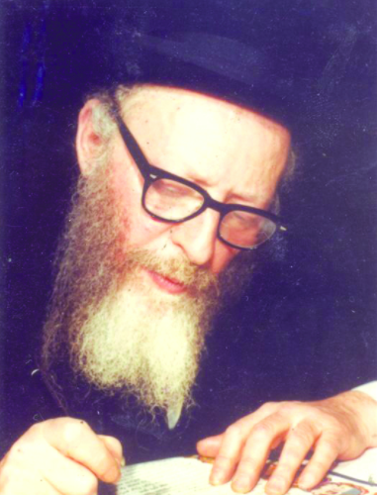

True to the path paved by his father and grandfather, of complete devotion to Limud HaTorah, R’ Shneur Kotler zt”l stood at the helm of Beis Medrash Govoha in Lakewood, NJ during its period of greatest expansion and growth. With his Ge’onus in Torah, his gentle manner, and humility, he led not only the Lakewood Yeshiva, but shouldered the burdens of Klal Yisroel.
R’ Shneur was born in 1918 to his father R’ Aharon Kotler in Slutzk, Poland, where his maternal grandfather, R’ Isser Zalman Meltzer, was Rosh Yeshiva and Rav. His early childhood was spent in Kletzk, where his father had become Rosh Yeshivah.
As a child of five, his giving and caring nature was already evident. He would often forgo supper, claiming that he was not hungry, if he felt it would be too much bother for his mother.
He later learned under R’ Boruch Ber Leibowitz in Kaminetz, and in 1940, joined his grandfather, R' Isser Zalman, in Yerushalayim. R’ Isser Zalman then headed the Eitz Chaim Yeshiva. R’ Shneur was greatly influenced by R’ Isser Zalman and other gedolim in Eretz Yisroel, with whom he formed a close bond, including R’ Yitzchok Zev Soloveitchik (the Brisker Rav), R’ Isaac Sher and R’ Yeckezkel Sarna.
Many commented on the striking similarity between R’ Shneur and his grandfather, R' Isser Zalman. He often visited the Gerrer Rebbe, who remarked about R’ Shneur, “This bachur is worth his weight in gold!” ⎪
When WWII erupted, a young yeshiva bachur named Yehoshua rushed to Kovno in an effort to obtain a visa to leave the country. He was hardly surprised, but dismayed, at the size of the line of people waiting for their turn to talk to the consul.

Waiting Desperately in Line as the Hour Passed
Dozens and dozens of people were in front of him. He had no choice but to take his place in line and wait. Hours passed. Yehoshua could not help but grow more anxious as the line hardly moved. What if they ran out of visas before his turn arrived? He felt himself beginning to panic, as he desperately tried to push himself forward.
A young man standing in front of Yehoshua turned around. Yehoshua flushed, embarrassed about having pushed. Then, without a word, the young man stepped aside and gestured for Yehoshua to take the place in front of him. Yehoshua stepped forward, glancing at the young man with awe. Such an act was true mesiras nefesh. Surely this young man was just as desperate to obtain a visa. Finally, Yehoshua reached the head of the line where he was issued a precious visa, as was the noble young man who had let him go ahead. This young man was none other than R’ Shneur.
After the turmoil of the war years, R’ Shneur was finally able to join his father in America, where he had founded Beis Medrash Govoha. When R’ Aharon passed away in 1962, R’ Shneur, who was only 44 at the time, assumed the heavy mantle of leadership. During the week of shivah for R’ Aharon, the lay leadership of the yeshiva entered the room where the family was sitting and proclaimed “Yechi Hamelech!” R’ Shneur broke into uncontrollable sobbing.

Barely 100 Bahurim in the Yeshiva
At the time R’ Shneur became Rosh HaYeshiva, Beis Medrash Govoha had barely 100 bachurim in the yeshiva, and some 35 young men in the Kollel. When R’ Shneur passed away, about 20 years later, the yeshiva had close to one thousand talmidim – about half of them in the Kollel and virtually all of them Bnei Torah over the age of 20.
Yet R’ Shneur led Lakewood to become a center of learning such as the world has not known in decades. R’ Shneur accomplished this difficult feat by running the yeshiva with an extremely delicate touch in dealing with others, using his gifts of mind and heart.
R’ Shneur spoke to each young bachur with the same derech eretz and deference that he would show to a venerable gadol. He never called anyone by his first name without prefixing it with “Reb.” He never made any personal demands on a talmid, for he felt he was there for the sole purpose of giving to the talmid.
R’ Shneur could face a Bais Midrash full of 400 people to deliver a shiur or shmuess, and see individuals. He would quickly scan the entire assemblage, and later be able to approach a talmid to discuss a point in the shiur, or call over another talmid whom he felt should have been present but was not.

Devoted Much Attention to Guiding the Community
R’ Shneur worked tirelessly with the administration and lay leadership to raise money for the ever-growing operating budget of the yeshiva. During the last 10 years of R’ Shneur’s life, Lakewood experienced the growth of its talmidim who went into business, settling in the community, while maintaining close contact with the yeshiva. To meet the needs of these families and the older Kollel members, the Lakewood Cheder and other schools were established. R’ Shneur devoted a great deal of attention to guiding the community and to overseeing the Cheder.
R’ Shneur spread Torah in countless communities throughout the world by establishing yeshivos and kollelim. If any yeshiva was in trouble, R’ Shneur was ready to contribute his time and energy with the same dedication that he devoted to his own yeshiva, thinking nothing of flying across the country for a day or two to resolve difficulties or to raise funds. In one of his last letters, R’ Shneur wrote that whenever he spoke at a fundraising affair for the yeshiva, he never mentioned Bais Medrash Govoha; he spoke only of the greatness and importance of Torah as a concept.

Great Concern for Soviet Jews
In 1971, when reports reached America that Soviet Jews were being permitted to emigrate to Eretz Yisroel, R’ Shneur called the national offices of Agudath Israel of America, urging that the topic of helping them be put of primary concern, stressing the historical dimensions of what was occurring, and volunteering his own time and effort. He carried a major part of the burden of the Be’er Hagolah school for Russian children.
When Iranian students began to come to America to escape the hazards of Khomeini’s government, R’ Shneur, participating at an Agudath Israel meeting, was the only one to paint the plan for a large-scale action, which was to prove truly visionary. ⎪
After a Yeshivah function in a New York City hotel, R’ Shneur stepped out to a waiting car and noticed five young people crowded on the back seat, to make room for him in the front. He stepped back and closed the door, refusing to enter: “There’s no room.” He was reassured that the bachurim in the back were managing very well. “No, they are not lap-children and we can’t expect them to ride back to Lakewood in such discomfort. I’ll get another ride.”
On a typical day he would arise early to learn before Shacharis, after which he would schedule personal meetings with talmidim, which were often interrupted by a barrage of telephone calls from all over the world. He gave a weekly shiur and periodic shmuessen, but he was forced to spend much of his time away from Lakewood, traveling almost daily to New York for conferences, parlor meetings, and other functions. He would fly almost weekly to other cities, and he would share in his talmidim’s simchos. Regardless of when he returned home, he would sit and learn until 3 am, still being interrupted at that hour for Klal and yeshiva affairs!
R’ Shneur once urgently requested a real-estate broker to arrange a second mortgage on his home. R’ Shneur had become aware of two parties undergoing extreme difficulties with their business, and he wanted to lend them $30,000 to tide them over their crisis. The yahrzeit of R’ Yosef Chaim Shneur ben R’ Aharon Kotler zt"l is on 3 Tammuz (1982). May his merit protect us. (The Torah Profile, "Rav Aharon Kotler", Olomeinu-Mador Ivri)

Reprinted from the Parshas Shelach 5781 email of The Weekly Vort.

